**Update: 17 September 2021**

Dear Students and Parents/Guardians/Carers

## ****COVID-19 INFORMATION FOR ALL STUDENTS****

## I would like to reinforce the Group’s approach around safer behaviours and actions that will help reduce the spread of COVID-19.

## It remains important for everyone, including those that are fully vaccinated, to follow the five key points below whilst studying on campus to help limit the spread of COVID-19 and to help keep everyone safe.

### **MANDATORY WEARING OF FACE COVERINGS**

All students, staff and visitors are **now required to wear a face covering in all college communal areas (indoors) and on college transport**, unless exempt. Colleges can require the wearing of face coverings under the government’s guidelines and there is clear evidence that face coverings reduce infection rates.

Students that are exempt are asked to have their exemption card visible or visit the colleges Wellbeing/Welfare Centre for a pass.

### **COVID-19 - HOME TESTING (TWICE A WEEK)**

All students are asked to perform TWO COVID tests a week at home. Home testing kits have been provided to all students and further supplies are available to collect from the main reception desks. DON’T FORGET TO RECORD YOUR HOME TEST RESULTS.

**Students are reminded to log their COVID test results on the college system and NHS system.** Guidance on how to record your results can be found on the Student Hub[Here](https://sites.google.com/peterborough.ac.uk/2022-ieg-student-home-testing/home)**.**

1. **REPORT A POSITIVE TEST OR COVID RELATED ABSENCE**

If you have COVID-19 symptoms or have **had** a positive (PCR or LFT) test result **you should NOT come to college and must inform us of your absence.**

Please inform the college by emailing:

* **Stamford College** – [safeguarding@stamford.ac.uk](mailto:safeguarding@stamford.ac.uk)
* **Peterborough College/UCP** – [safeguarding@peterborough.ac.uk](mailto:safeguardingPRC@peterborough.ac.uk)

## ****COVID-19 – VACCINE****

If you’re aged 16 or over, you’re now eligible to receive your COVID-19 vaccine, which you can get at a local walk-in clinic. Although the NHS will contact you when it's your turn to get the vaccine, there are walk-in clinics available for you to attend where you can get your vaccine there and then.

We strongly encourage all those who are eligible to have the vaccine to do so, so that you can enjoy the full-range of opportunities available at college without disruption to your studies. Ensuring our college community is as safe as possible is our top priority. [You can find your nearest drop-in clinic here.](https://bit.ly/3B4Wjiz)

1. **HOW TO STOP COVID-19 SPREADING – SAFE BEHAVIOUR AND ACTIONS**

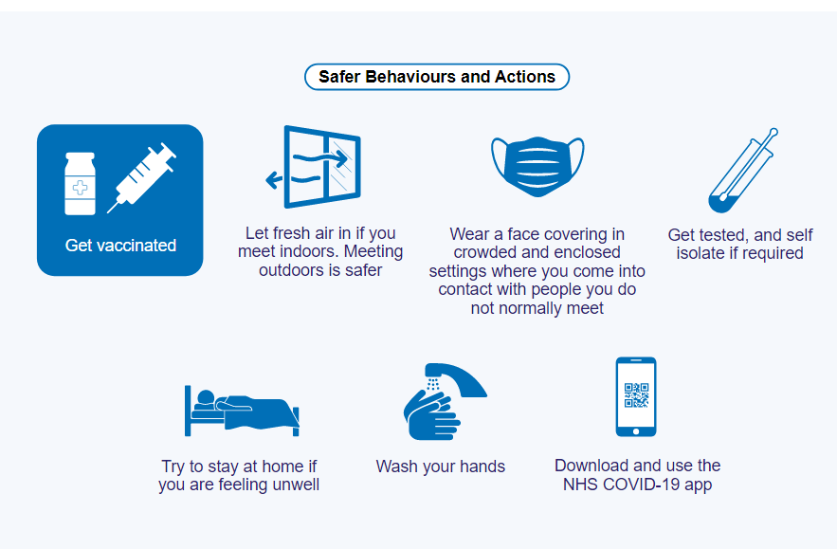

As a college, we are doing all that we can to protect our students and staff. Your health and safety remain our absolute priority and we would like to thank you for your support.

We would like to wish you well with your studies this year and remind you that should you require any support around your mental health and wellbeing, please do get in contact with your student mentor or a member of the college’s wellbeing/ safeguarding team.

Best wishes



Sarah Young

Vice Principal Student & Staff Experience - Inspire Education Group